**UZS: The Reckoning**

Chaz Balts, Nic Kibler, Weston Laity, Dillon Wertman

**Part 1: Concept**

Platform

The platform for this game would primarily be computer. As a secondary platform of choice, this game could easily be adapted to a joystick/button arcade game. While the game could be ported to console and handheld, the top-down 2D style might be more attractive for computer and arcade gamers.

Premise

You are a Russian ex-General thrown into the harsh frontier of Russia during WW1 as hordes of undead comrades hunger for your flesh. In the bitter, dark winters of Russia, no one can hear you scream. Quick thinking and even quicker movement will keep you alive, how long will you last?

Target Rating

The rating will be Mature. The mature content flag in this game arises from the existence of blood and violence.

Target Market

The market for this game will consist of gamers who enjoy a challenge and a solitary experience. A target age range would be 17 - 25. The mature content will include the oldest teenagers and the experience of the game might reach to the youngest adults, which may include college college students looking to kill some time.

Goals

The player will have a sense of fear and suspense from the horror aspect of being surrounded by not just zombies, but zombies of your dead comrades. Challenge will also be experienced through the fast-paced survival aspect. Nostalgia will be experienced through the homage paid to zombie shooters like Call of Duty Zombies.

**Part 2: Game Story Elements**

Backstory

Alexander Samsonov was a Russian General during the height of WW1 who, after the Battle of Tannenberg which resulted in the complete destruction of the russian army, decided to fake his own death to avoid execution by the russian government. The souls of his dead comrade have reanimated their corpses and they seek to devour him as punishment for his dishonor. As the horde of undead comrades surrounds him, General Samsonov makes his final stand.

Synopsis

The player, as General Samsonov, survives as long as he or she can. Surviving in this game combines eluding zombies but also selecting weapons effectively. The player defeats zombies in a forest to start, but moves to a city later on. The city will provide little comfort and as the last of the zombies the player is use to killing are killed, a monstrosity of melded flesh will confront Samsonov.

**Part 3: Game Elements**

Challenge

The game will feature constantly moving enemies that will advance toward the player. Samsonov is surrounded by his dead comrades, and they hunger for vengeance.  Ammo is a resource that must be used efficiently. Samsonov isn’t going to have a large reservoir of ammo to draw from. Lastly, points must be used effectively to upgrade to the best weapon. Samsonov becomes more comfortable with using more advanced weaponry as he defeats zombies, but choosing the best weapon may prove difficult.

Strategies

In a survival setting, quick reflexes allow a player to dodge enemies, and quick thinking allows a player to prioritize which enemies to kill first. While the game can’t be won on dodging alone, quick reflexes and thoughts keeps the player alive longer. To conserve ammo, the player should make every bullet count. The player can be tactical in eliminating zombies, or the player can fire wildly and meet a swift end. Selecting weaponry and spending points wisely encompasses assessing the current situation and reacting to it. Also taking into account one’s skill with certain guns can play a major part in selecting the right weapon. Lives and ammo can also be bought. A player can buy different guns for variety, or they can balance buying ammo, lives and guns, for longevity.

Level Structure

There will be 2-3 rounds, each round taking the place of a “level”. The player advances to a new round by killing a set number of zombies on the previous level. Each round zombies will get harder to kill, increase in number, and some zombies will become faster. Some zombies will drop ammo/health. The player will be able to move around the entire map of a round. Between each round there will be a standby phase where the player can buy guns using a store menu. This standby phase will last for as long as the player remains in the store menu. Every round, the environment changes. The player might move from a forest area to a city area. This is significant because in the Battle of Tannenberg in which Alexander Samsonov fought first took place in a forest, and then moved into a city. In the last round, the player will be confronted with a boss. Defeating the boss means victory for the player.

Environmental Design

Forest Background used in game:

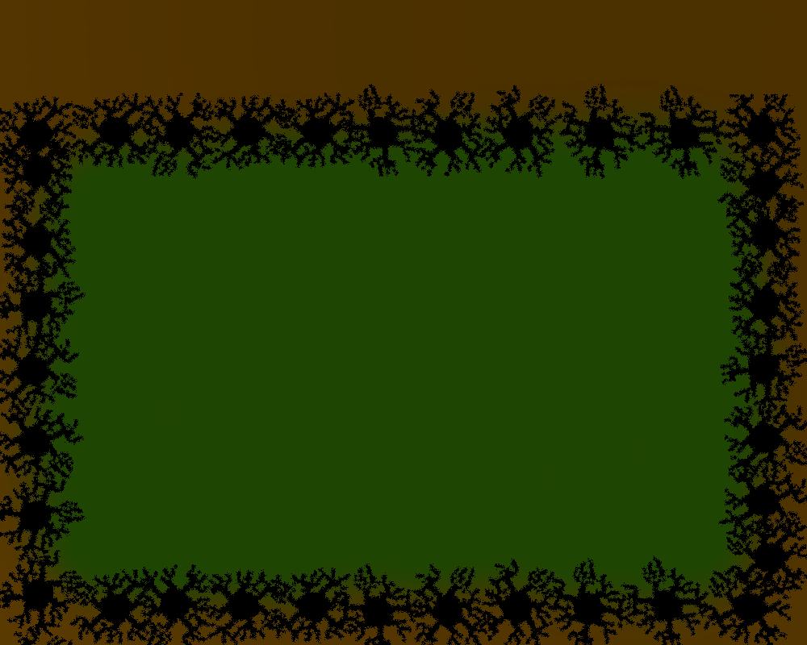

Interface Design

Player Control

The player controls Samsonov’s movement through the ‘W’ ‘A’ ‘S’ and ‘D’ keys. The player controls firing weapons with the directional keys.

Active Interface

**Title Screen:**

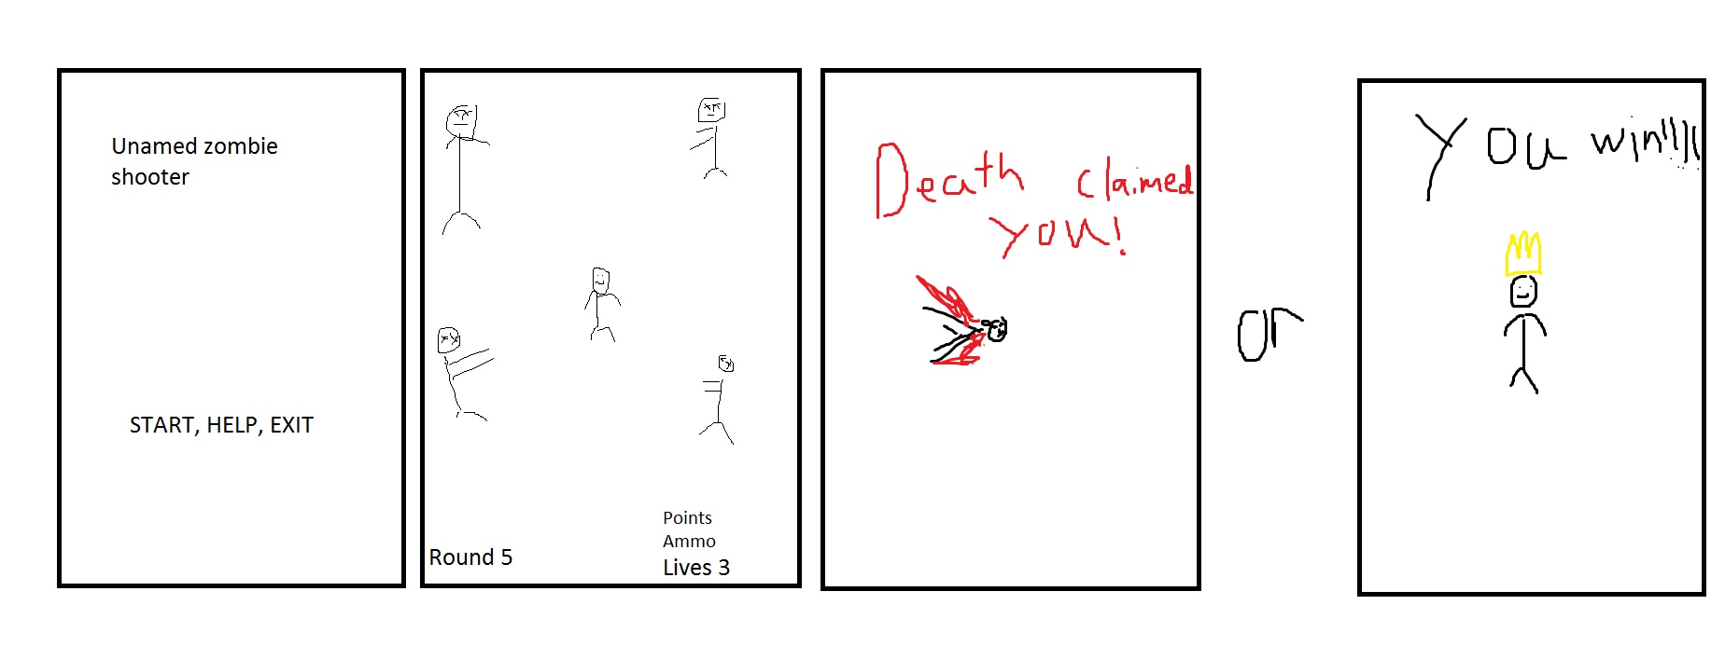

**Menu:**

The active interface of our game will be a menu system where the player can purchase guns, ammo, lives, and simply rest in between rounds. The left side of the rectangle shaped menu will contain gun options. The player can choose a gun and then press the buy button at the bottom right of the menu. The right side of the menu will contain ammo for each of the guns, and will be selected similarly to guns. Health can be bought by clicking a button at the bottom of the gun selection area, and is located to the left of the buy button. At the far bottom right corner of the menu, a button labeled done can be clicked to return to the game and a new round will start.

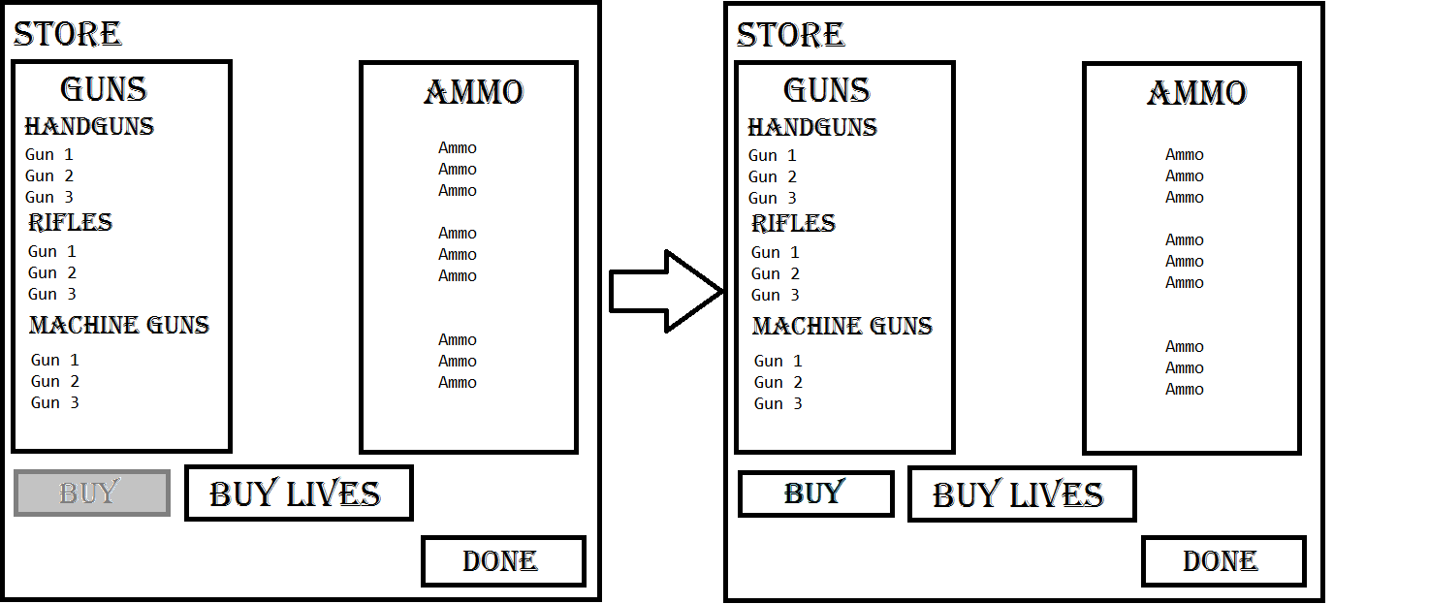

Passive Interface

**Game Screen:**



**Status:**

The passive interface will be a bar that displays health, ammo, and rounds at the top of the screen. Health will take up a majority of the center space, while ammo and round numbers will sit on either side of the health bar, just underneath the ends.



HEALTH

ROUND:

#

AMMO:

###

Concept Art



Figure 3: Pistol Sprite

Figure 4: Zombie Sprite

Figure 1: Rifle Sprite

Figure 2: Knife Sprite